**LAB 2 TASK**

**1) VER**

**The VER command is used to find the exact versions of DOS.**

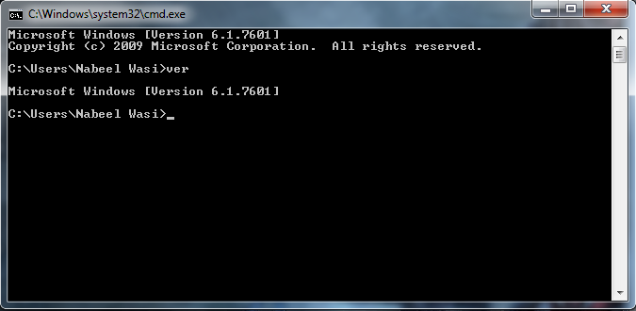

**2) CLS**

**This command is used to clear the screen.**

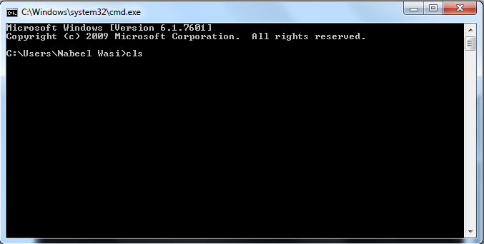

**3) LABEL**

**This command adds, modifies or changes the volume label of a disk.**

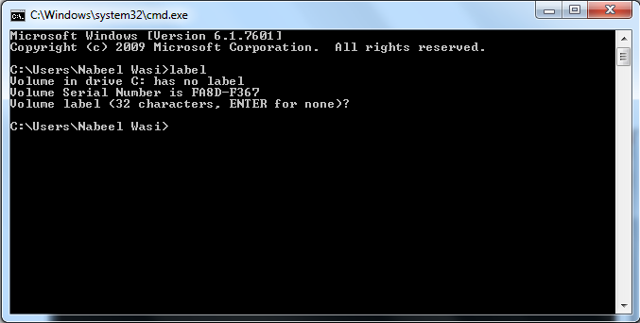

**4) VOL**

**This command is used to view a disk’s volume label.**

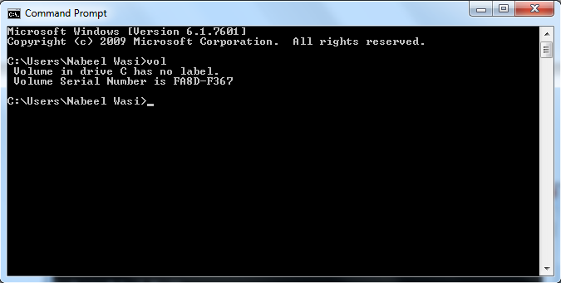

**5) DIR**

**This command will produce a directory listing from the default drive.**

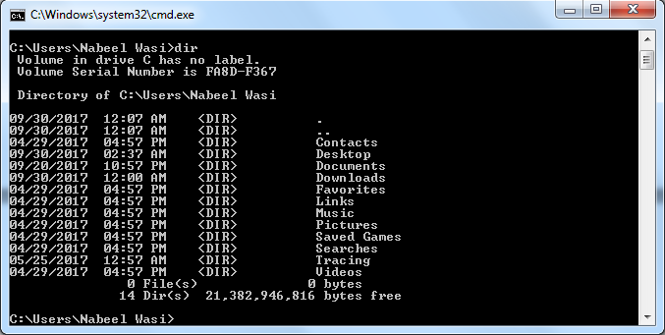

**6) MD**

**This command is used to create a new subdirectory.**

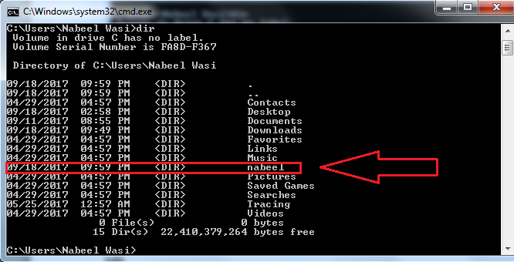

**7) RD**

**This command is used to remove a directory.**

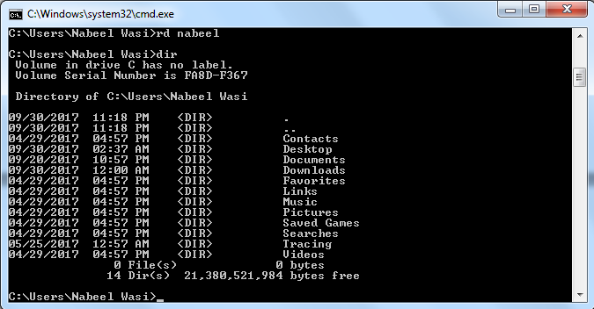

**8) CD**

**This command is used to change the current directory to a new current directory.**

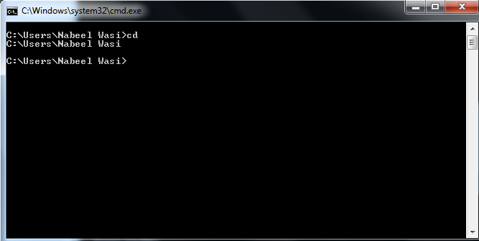

**9) TREE**

**This command is used to view directory listing in a hierarichal structure.**

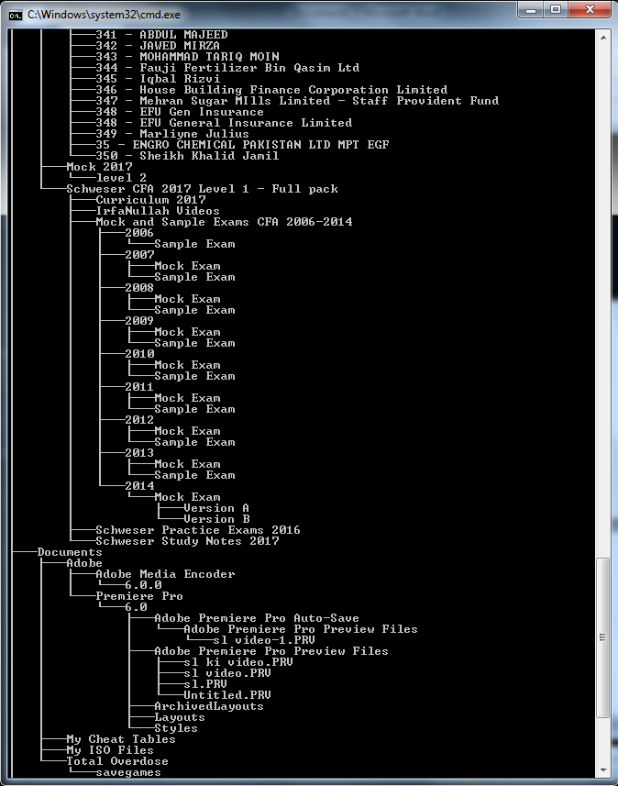

**10) REN**

**This command is used to rename a file.**

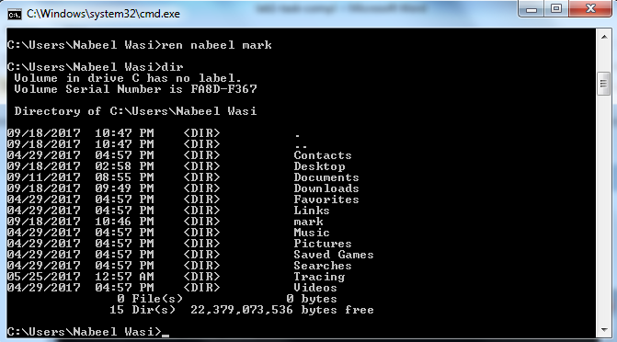

**11) DEL**

**This command is used to delete files from the disk.**

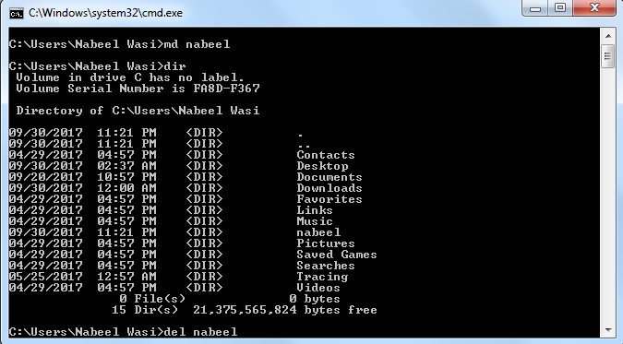

**12) TYPE**

**This command is used to view the contents of a text file.**

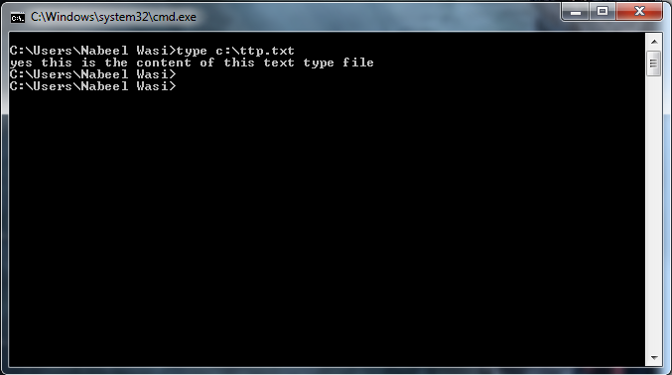

**13) COPY**

**This command is used to copy files from directories as well as to and from logical devices.**

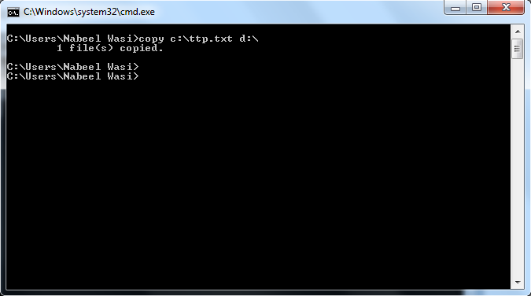

**14) XCOPY**

**This command is also used to copy files but it can also create destination subdirectories.**

